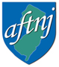Health and Safety is
a union issue!!
- it’s about our health and safety
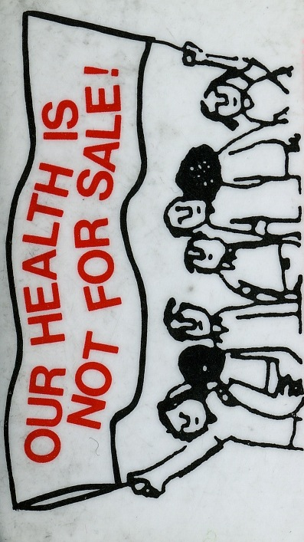
- “Our health is not for sale”: from Italian workers in the 1960s, this phrase means we won’t sell our health for wages, benefits or a shortened or miserable life, that we will fight for this inherent right
- we don’t have the same goals as the other “players”, especially the employer/boss
- it’s a great organizing issue, and always has been (eg. lack of respect and dignity at work are work hazards or stressors)
- collective solutions are best, for all of us
- we have more power collectively, rather than individually, to get things fixed the way they should be done
- health and safety is not a neutral topic
- all laws, and especially health and safety ones, are the result of negotiations and concessions
- studies show that the presence of a union improves working conditions and reduces work-related injuries and illnesses, partly because the law is better enforced
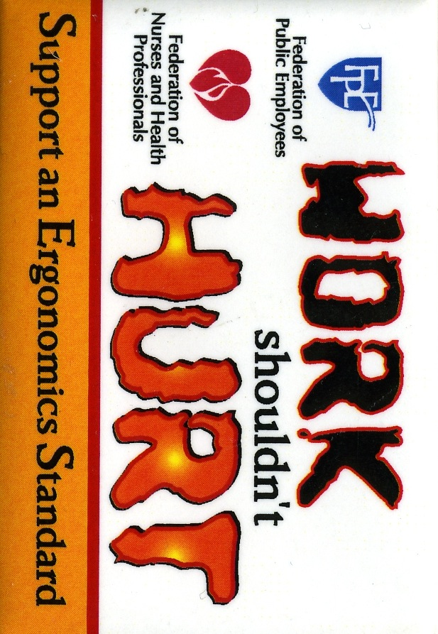
- it’s a bargaining topic, like many others

You have the right to a safe workplace!
Report your concerns to your union, for additional assistance email Joyce Sagi, Health & Safety Chair at safety@aftnj.org

